## Summary

Claudiu Creanga

Limesharp Store Locator Module

User Guide

Prepared By:

[limesharp.net](http://limesharp.net) T 0845 5202 400 E [sales@limesharp.net](mailto:sales@limesharp.net)

This store locator extension allows customers to find your physical stores on a Google map.

Module homepage: http://claudiucreanga.me/magento2-store-locator-stockists-extension/

Possible use cases:

* Show physical stores on the website;
* Show stores that are stocking your products.

Why use it:

* Customers can find the nearest store to their location;
* Customers can get directions to the store;
* Customers can see detailed information about your store, i.e it is closed or open now.

What you can do with this extension:

This extension allows you to insert stores on a Google map via latitude and longitude so that the customer can find them. All you have to do is to insert the name of the store, latitude and longitude of that store and then the customer can find which store is nearest to their location. They can search via postcode, city or use their geolocation.

Additionally, you can provide more information about the store in these attributes: address, city, country, postcode, link, telephone, email, image.

The extension provides import and export functionality so that you can write everything in a csv file and then import it easily.

The search functionality allows customer to search via their postcode or city so that the nearest store to them is returned.

Features:

* Details: name, address, city, country, postcode, link, telephone, email;
* Images: upload images of your stores;
* Import: import your stores from a csv file;
* Export: export stores to a csv file;
* Interactive map: stores positioned on the map via longitude and latitude;
* Geolocation: show nearest stores to user (in chrome only via https);
* Search: search functionality in the sidebar;
* Directions: show directions from user location to store (driving, walking, cycling or public transport);
* Map Styles: choose from over 10 different map styles to fit your store;
* Breadcrumbs: show/hide breadcrumbs;
* SEO: edit titles, meta descriptions and keywords;
* Url: chose your url where your store locator appears;
* Radius: Select and style your radius in settings;
* Unit: Chose between miles and kilometres;
* Pin: Use custom map pin;
* Responsive: Mobile responsive templates;
* Templates: Choose from 3 different templates;

Prerequisites:

* Magento 2.1+
* PHP 7+

How to use it:

Once installed via composer or via magento marketplace you can see it in the admin under content menu:

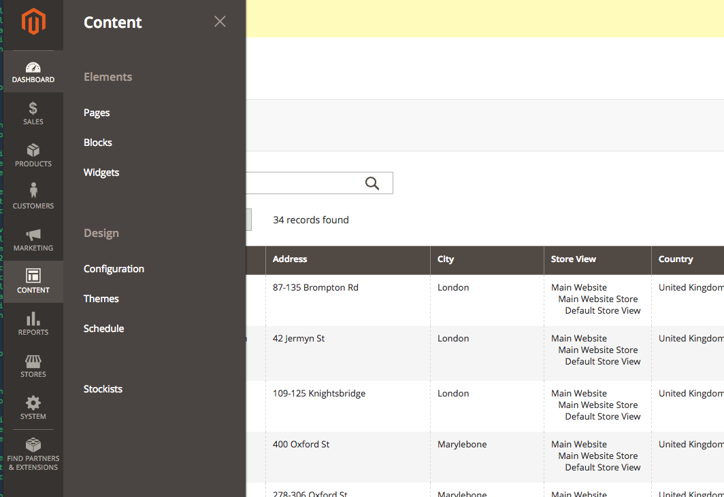

You can edit, add, import and export stores there:

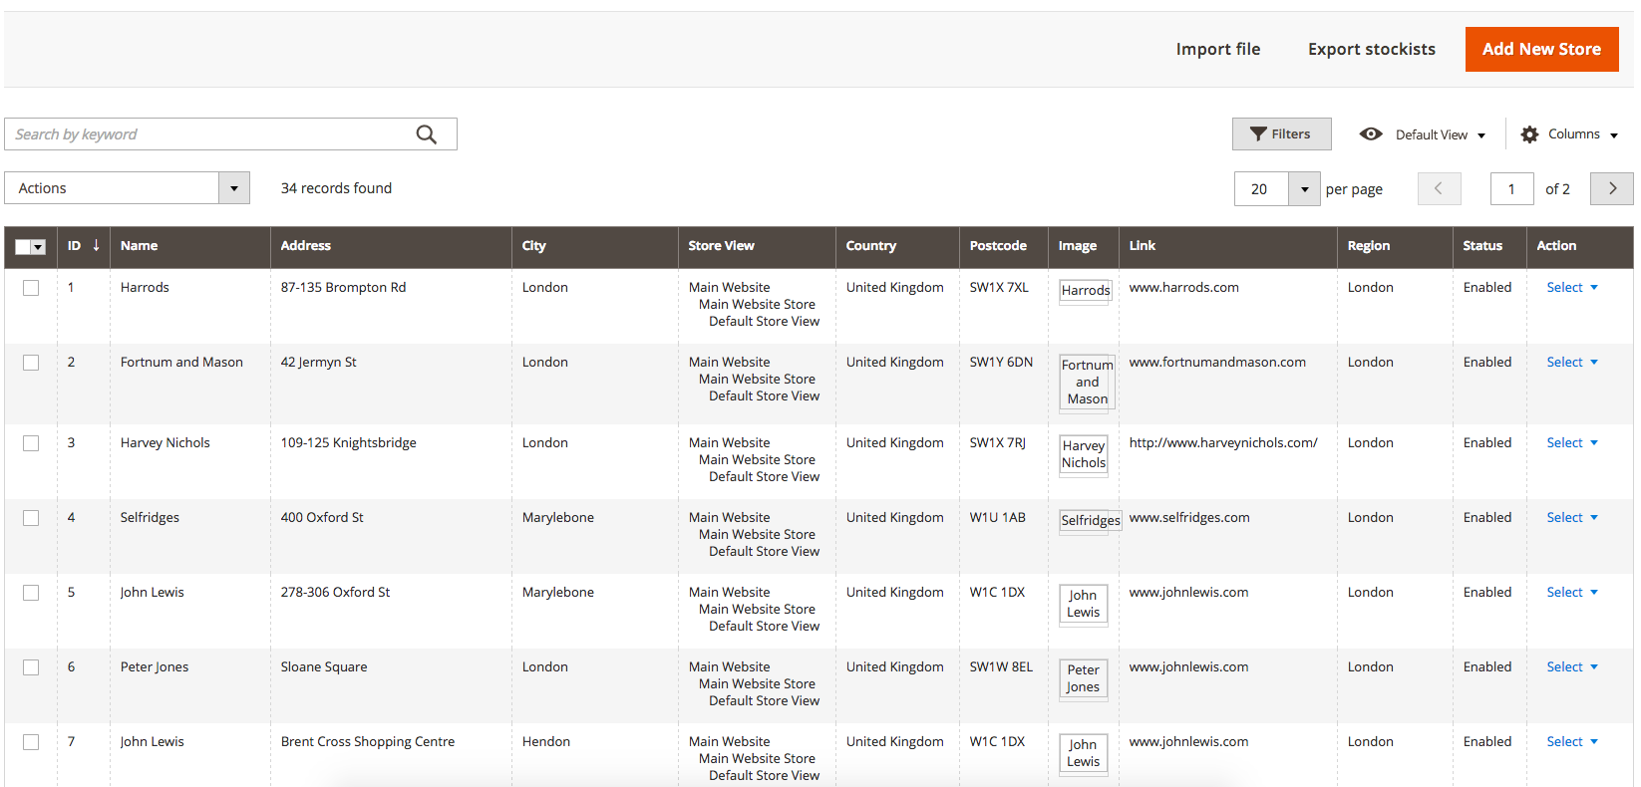

If you want to import files, keep in mind that:

* The csv file needs to be comma separated and values should be quoted;
* check the sample csv file in documentation folder;
* name, latitude and longitude are required;
* country field should be the 2 letter ISO code. Example: GB for United Kingdom and US for USA;
* image should be the path of the image which is built from the first to letters separated by slash and then the name of the image. Example: for image test.png the path is /t/e/test.png. The image should be placed in folder pub/media/limesharp_stockists/stockist/image/t/e/ (last 2 letters changed of course);
* To make sure your csv file is formatted correctly, you can open it in a text editor. It should look like this (comma separated and quoted values):

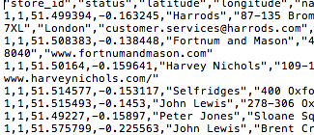

Additional settings can be found in Stores > Configuration:

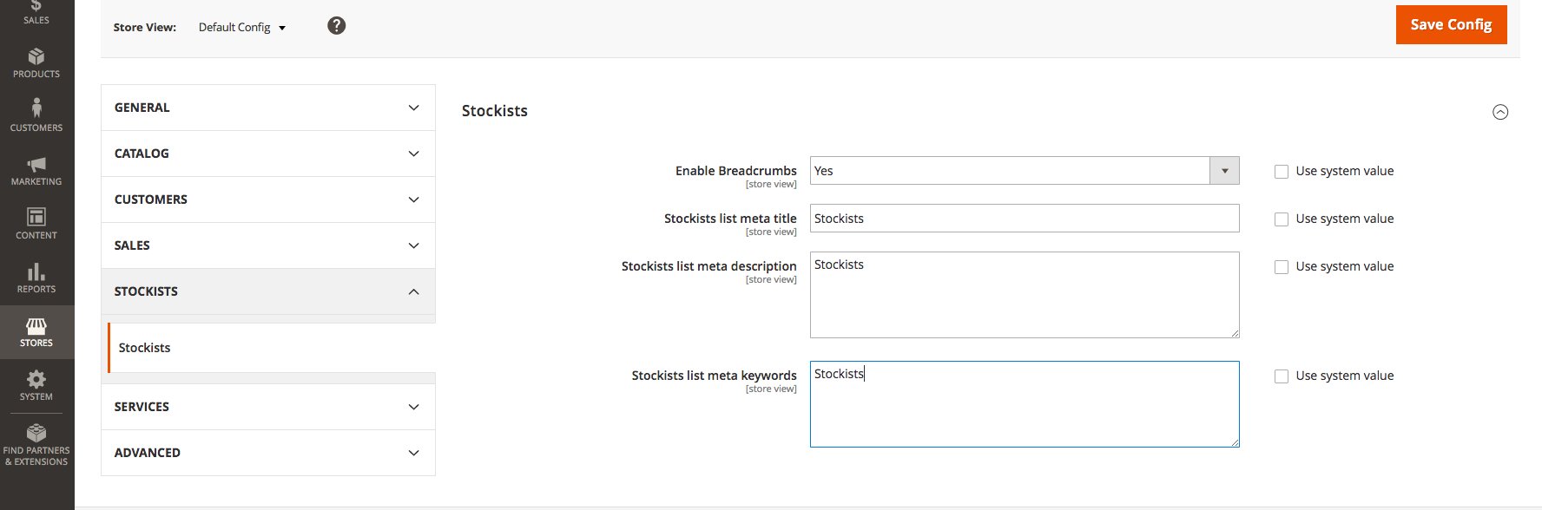

This extension is open source, feel free to contribute or submit bugs:

<https://github.com/ClaudiuCreanga/magento2-store-locator-stockists-extension>